**Impacting the Rate of a Chemical Reaction**

**Directions:**

1. *You will design an experiment to test a variable on reaction rate*
2. *Read the background information*
3. *Choose a variable: temperature, concentration, or surface area*
4. *Create a purpose, question, hypothesis, and prediction by filling in the blanks*
5. *Write a brief procedure-* 
   1. *remember to test only ONE variable and measure ONE variable*
   2. *make procedure detailed enough for me to follow at home on my own*

**Background**

Chemical reactions are part of life. Your body is constantly converting molecules from your food into the molecules that make up the parts of you. These reactions would occur slowly without enzymes that act as catalysts. Adding catalysts are one method of speeding up chemical reactions. These are needed to bring the molecules together and cause these to interact in order to react. Increasing temperature, concentration, and surface areas are other methods of increasing reaction rate. A simple reaction involves alka-seltzer (or antacids) tablets and water. When placed in water, these tablets effervesce or produce carbon dioxide bubbles as the sodium bicarbonate reacts with water. The reaction rate can be measured by timing the production of bubbles. If bubbles are produced over a long period of time, then the reaction rate is slow. If bubbles are produced quickly and stop fizzing in a short period of time, then the reaction rate is considered fast. A summary of the reaction is shown below:

Chemical Reaction:

Alka Seltzer tablets + water → bubbles

Sodium bicarbonate dissolves into ion form and reacts with citric acid to make bubbles and water

The time of the reaction is the time over which bubbles form.

**Purpose**

The purpose of this lab is to observe the effect of surface area on the rate of a chemical reaction.

(2 points)

**Question**

What is the effect of surface area on reaction rate?

(2 points)

| **Hypothesis**  Increasing the surface area will increase the rate of the reaction because  the molecules will make them collide with more molecules being added to the equation.  ___________________________________________________________________________________  (5 points) |
| --- |

| **Prediction**  If the surface area of the reactants is increased, then the rate of the reaction will  decrease.  (3 points) |
| --- |

**Protocol**

| **Every Test Needs** | **Options for different variables** |
| --- | --- |
| * 4 alka seltzer tablets * graduated cylinders * timer * 4- 50 mL beakers * enough water to fill each beaker with 50 ml of water | balance to measure mass of crushed tables if needed (concentration) |
| access to cold, room temp, mild, and hot water if needed (temperature) |
| thermometer- to measure temperature of water (temperature) |
| mortar and pestle- to break or crush tablets if needed (surface area) |

* design a protocol that will test the assigned variable. You must complete 3 different increments of the variable (for example, three different temperatures, surface areas, or concentrations)
* use the first steps as a guideline and use the materials listed (14 points)

| 1. My team and myself added one tablet and waited for it to fully dissolve. 2. We added a two halves of a seltzer tablet and waited for it disappear 3. We added a seltzer tablet and split it into four tablets and waited for it to disappear   4. (crush) |
| --- |

**Analysis**

1. [**Create a graph**](https://nces.ed.gov/nceskids/createagraph/) **to represent your data. Choose a line or bar graph depending on the variables used.** (title-2, y axis title and units-2, x axis title and units-2, no data labels-3, scale changed to fit graph-6 = 15 points) 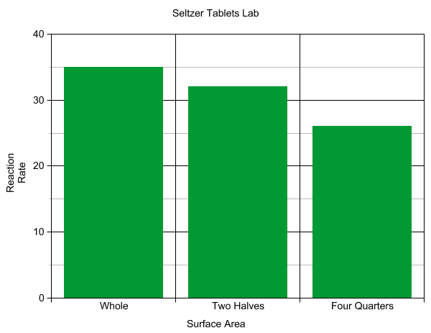
2. **State a conclusion by filling in the statements below.** (3 points per statement = 9 points)
3. **You should discuss the trend or lack of trend in the data. Use actual data points, highest and lowest or slope or pattern.**

| The data shows that as the Surface Area increasesthe rate of the reaction rate. |
| --- |
| For example, The time of a whole tablet is greater than the tablets split into four pieces.  ________________________________________________________________________________ |
| In conclusion, increasing the Surface Area **did** increase the rate  of the reaction. |